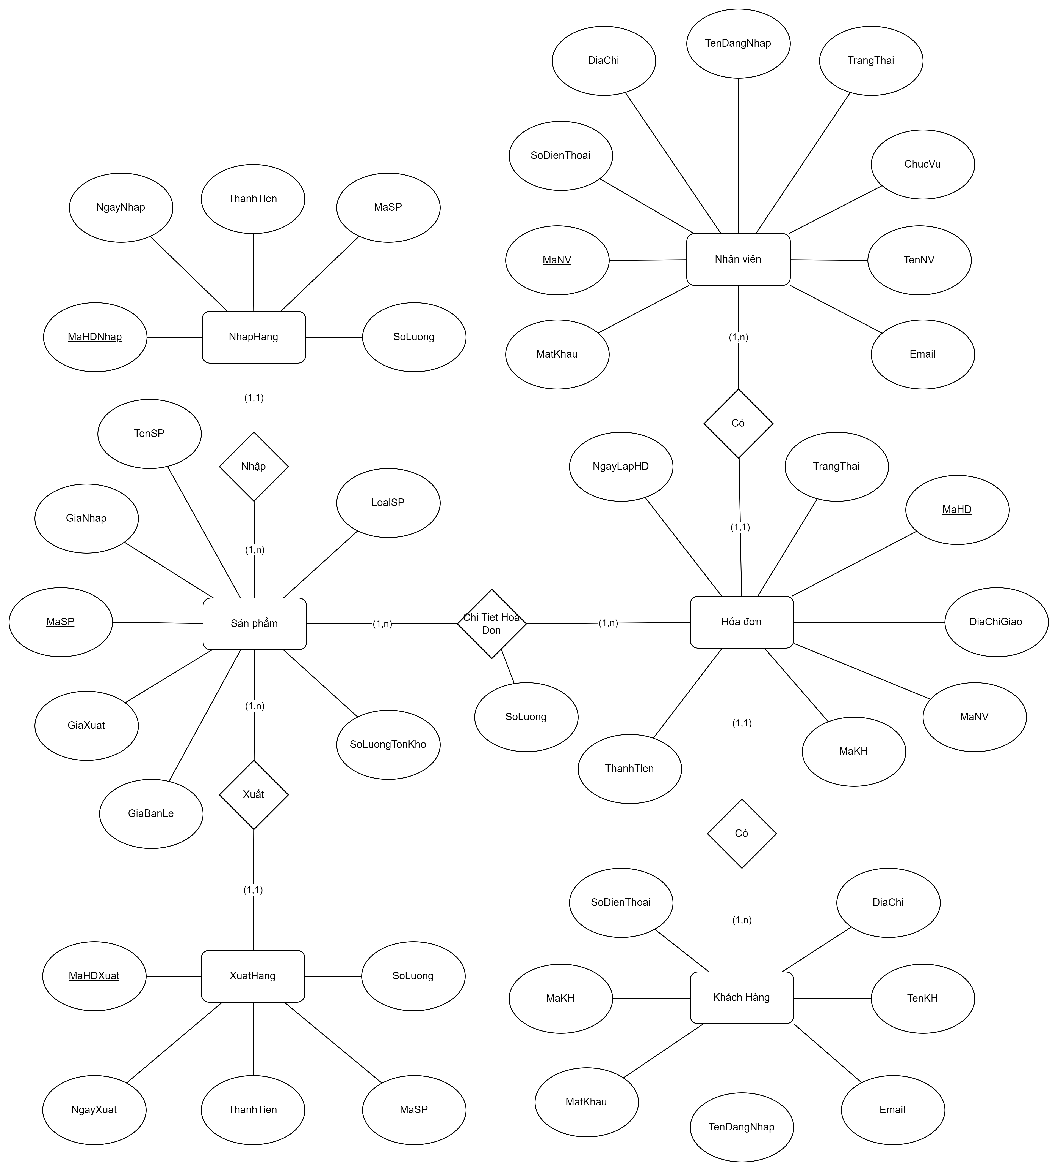

KhachHang(MaKH, TenDangNhap, MatKhau, TenKH, SoDienThoai, Email, DiaChi)

NhanVien(MaNV, TenDangNhap, MatKhau, TenNV, SoDienThoai, Email, DiaChi, ChucVu, TrangThai)

SanPham(MaSP, TenSP, LoaiSP, SoLuongTonKho, GiaBanLe, GiaNhap, GiaXuat)

HoaDon(MaHD, MaNV, MaKH, NgayLapHD, TrangThai, DiaChiGiao, ThanhTien)

ChiTietHoaDon(MaHD, MaSP, SoLuong)

NhapHang(MaHDNhap, NgayNhap, MaSP, SoLuong, ThanhTien)

XuatHang(MaHDXuat, NgayXuat, MaSP, SoLuong, ThanhTien)